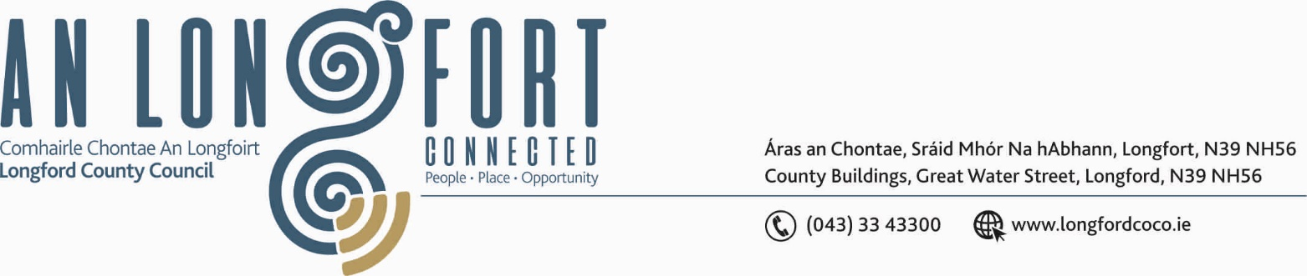

BALLYMAHON MUNICIPAL DISTRICT

18th September 2020.

To: Each Member of Ballymahon Municipal District.

Dear Member,

You are requested to attend Meeting of Ballymahon Municipal District to be held in Ballymahon Community Library on Thursday, 24th September 2020 at
4.00 p.m. to transact business, as set out on the Agenda hereunder.

Yours sincerely,
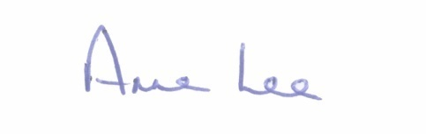

_______________
Anne Lee,
Meetings Administrator.

AGENDA

Prayer before meeting.

1. Confirmation of Minutes of the of Ballymahon Municipal District Meeting held on the 23rd July 2020 – copy enclosed.

2. Matters arising from Minutes.

3. Declaration of Interest by Members.

4. Management Report - enclosed.

5. Consideration of applications received under the 2020 Community Grant Support Scheme.

6. Notices of Motions, submitted by Councillors, as listed hereunder –

Councillor Paul Ross.

“That the entrance to Shannon Park Estate, Edgeworthstown be dug out and resurfaced with a hard wearing surface, due to consistent potholes forming at this entrance.”

Councillor Mick Cahill.

“That Longford County Council provides funding for the repairs to the wall in Abbeyshrule Graveyard.”

“That Barry Village footpath restoration be included in the Town and Village Scheme as it is in a very poor condition.”

“I call on the Council to remove the dangerous bend on the Clunta School end of the recently improved 1km stretch of road on the R398.”

Councillor Pat O’Toole.

“I call on Longford County Council to provide funding for a Low Cost Safety Scheme at the junction of the Cloncallow Road (L52166) with the R392 at Cloncallow, Ballymahon in the interests of public safety.”

Councillor Gerard Farrell.

“That Longford County Council acquires a property to develop a Digital Hub in Lanesboro.”

“That Longford County Council ring fence a sum of money from our Municipal Allocation for 2021 to support Just Transition applications.”

“That Longford County Council Roads Department erect vehicle activated speed signs on the approach roads to Newtowncashel and Killashee villages.”

7. Correspondence – enclosed.
- Correspondence received from Féileacáin (Stillbirth and Neonatal Death Association of Ireland) regarding “Wave of Light” Campaign
on the 15th October.

